As a big fan of Disney Parks and economics, I was interested in exploring how economic factors relate to the number of visitors to the parks. To investigate this, I used to wait times from different rides at Walt Disney World to compare changes in wait times with changes in economic variables that affect the US economy. Since daily visitor data is not publicly available, wait times were used as a proxy to approximate park attendance.

The Economic Factors chosen are:

* Unemployment Rate
* Interest rates
* Inflation

Lastly, I am interested in seeing the relationship between the wait times and the Walt Disney Company’ share price on the market (TICKER: DIS)

The data were obtained from FRED and from NASDAQ, then I compiled in a single file using the first of each month as reference

The rides selected for the study are based on the four different parks at the resort, which include Magic Kingdom, Epcot, Animal Kingdom, and Disney's Hollywood Studios. Water parks and other recreational spaces were not included in the study. Another criterion considered when selecting rides was to choose one thrill ride and one family ride to cover a wider range of variables affecting wait times.

The rides selected are:

Magic Kingdom

* Buzz Lightyear's Space Ranger Spin (Family)
* Space Mountain (Thrill)

Epcot

* Spaceship Earth (Family)
* Soarin' Around the World (Thrill)

Animal Kingdom

* Kilimanjaro Safari (Family)
* Expedition Everest (Thrill)

Disney’s Hollywood Studios

* Toy Story Mania (Family)
* Rock 'n' Roller Coaster (Thrill)

The datasets were obtained from

<https://touringplans.com/walt-disney-world/crowd-calendar#DataSets>

Questions to be answered:  
1. Is Unemployment related to Disney World visitors?

2. Is Interest rate related to Disney World Visitors?

3. Is Inflation related to Disney World Visitors?

4. Is the Disney company share price related to Disney World Visitors?

5. Are the parks having differences in how this affect them?

6. Are these economic factors affect families more than other groups of travelers?

Hypothesis:

1. Yes, unemployment is one of the factors that affects people’s decision
2. High interest rates are associated with high inflation, so I believe they would be determinants for people’s decision
3. Answered in 2
4. Since The Disney company is a highly diversified company, the share price should not be highly affected by how many visitors the theme parks division has.
5. I believe Magic Kingdom will have more noticeable changes since it is the most popular park
6. Family travelling involves higher expenses which makes them more responsive to economic factors

Data Limitations:

It's important to note that using wait times as a proxy for park attendance has limitations, as wait times may be influenced by other factors such as ride closures, capacity, and changes in park operations, in addition to changes in the number of visitors. Nonetheless, this approach can still be an interesting way to explore the relationship between economic factors and park attendance. Additionally, it's important to keep in mind that the Walt Disney Company's stock price may be influenced by external factors beyond the performance of its theme park division. There is some data missing from certain months, especially during the COVID-19 Pandemic.

Analysis

Step 1: Cleaning the data

Excel:

* Eliminate SACMIN and date (Delete column)
* Separate Date from Time (Tool: text to column)
* Formatted Columns
* Remove Duplicates

SQL

* Trim Whitespace
* Eliminate null values and under 0 values

Step 2: Exploratory Analysis:

* Check for outliers and anomalies
* Explore relationships between variables:
* Identify any trends or patterns:
* Analyze differences between parks
* Investigate differences across traveler groups

Step 3: Findings

Let’s answer the questions establish to confirm or refute my hypothesis:

1. Is Unemployment related to Disney World visitors?

Findings: According to experts, an unemployment rate above 5% is considered high. Although the trend line showed a noticeable relationship, the correlation was not strong enough to make significant assumptions.

<https://www.investopedia.com/terms/u/unemploymentrate.asp#:~:text=In%20general%2C%20most%20experts%20deem,on%20what%20constitutes%20healthy%20unemployment>.

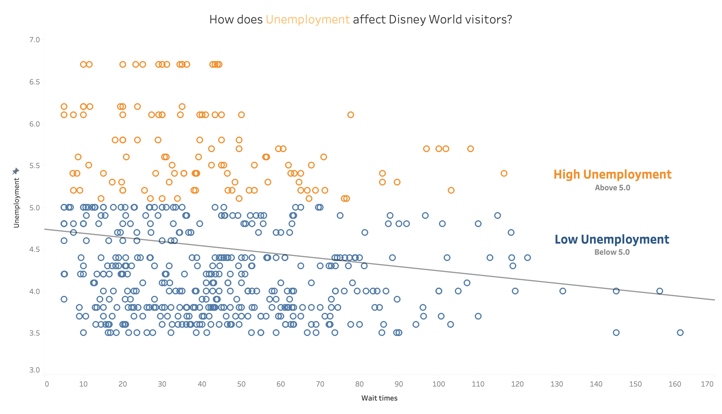

1. Is Interest rate related to Disney World Visitors?

Findings: Surprisingly, there is an inverse relationship between the interest rate and the average ride wait times. The data shows that a 5.5% interest rate resulted in the highest average ride wait times, even though it was the highest interest rate in the study. The second and third highest interest rates with the longest wait times were 4.75% and 4.5%, which are also considered high interest rates.

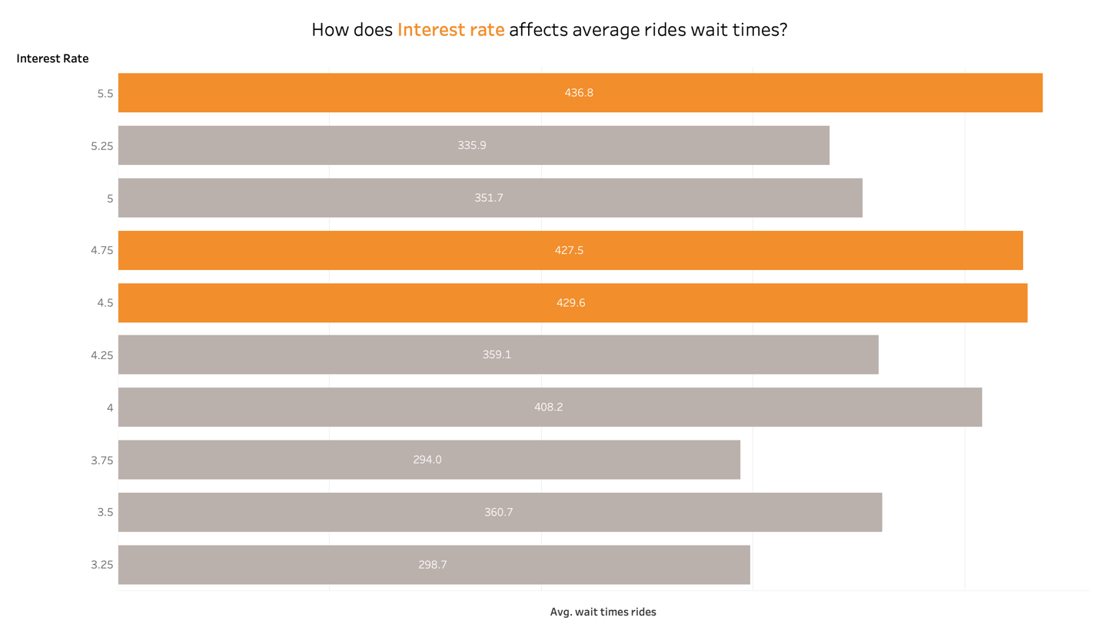

1. Is Inflation related to Disney World Visitors?

Findings: According to the Federal Reserve, an acceptable level of inflation would be below 2%. So, I have set a color difference between months with inflation at 2.5% or higher. The correlation seems to be present, but in a small way. It could have an effect, but not in an abrupt manner. <https://www.federalreserve.gov/faqs/5D58E72F066A4DBDA80BBA659C55F774.htm>)

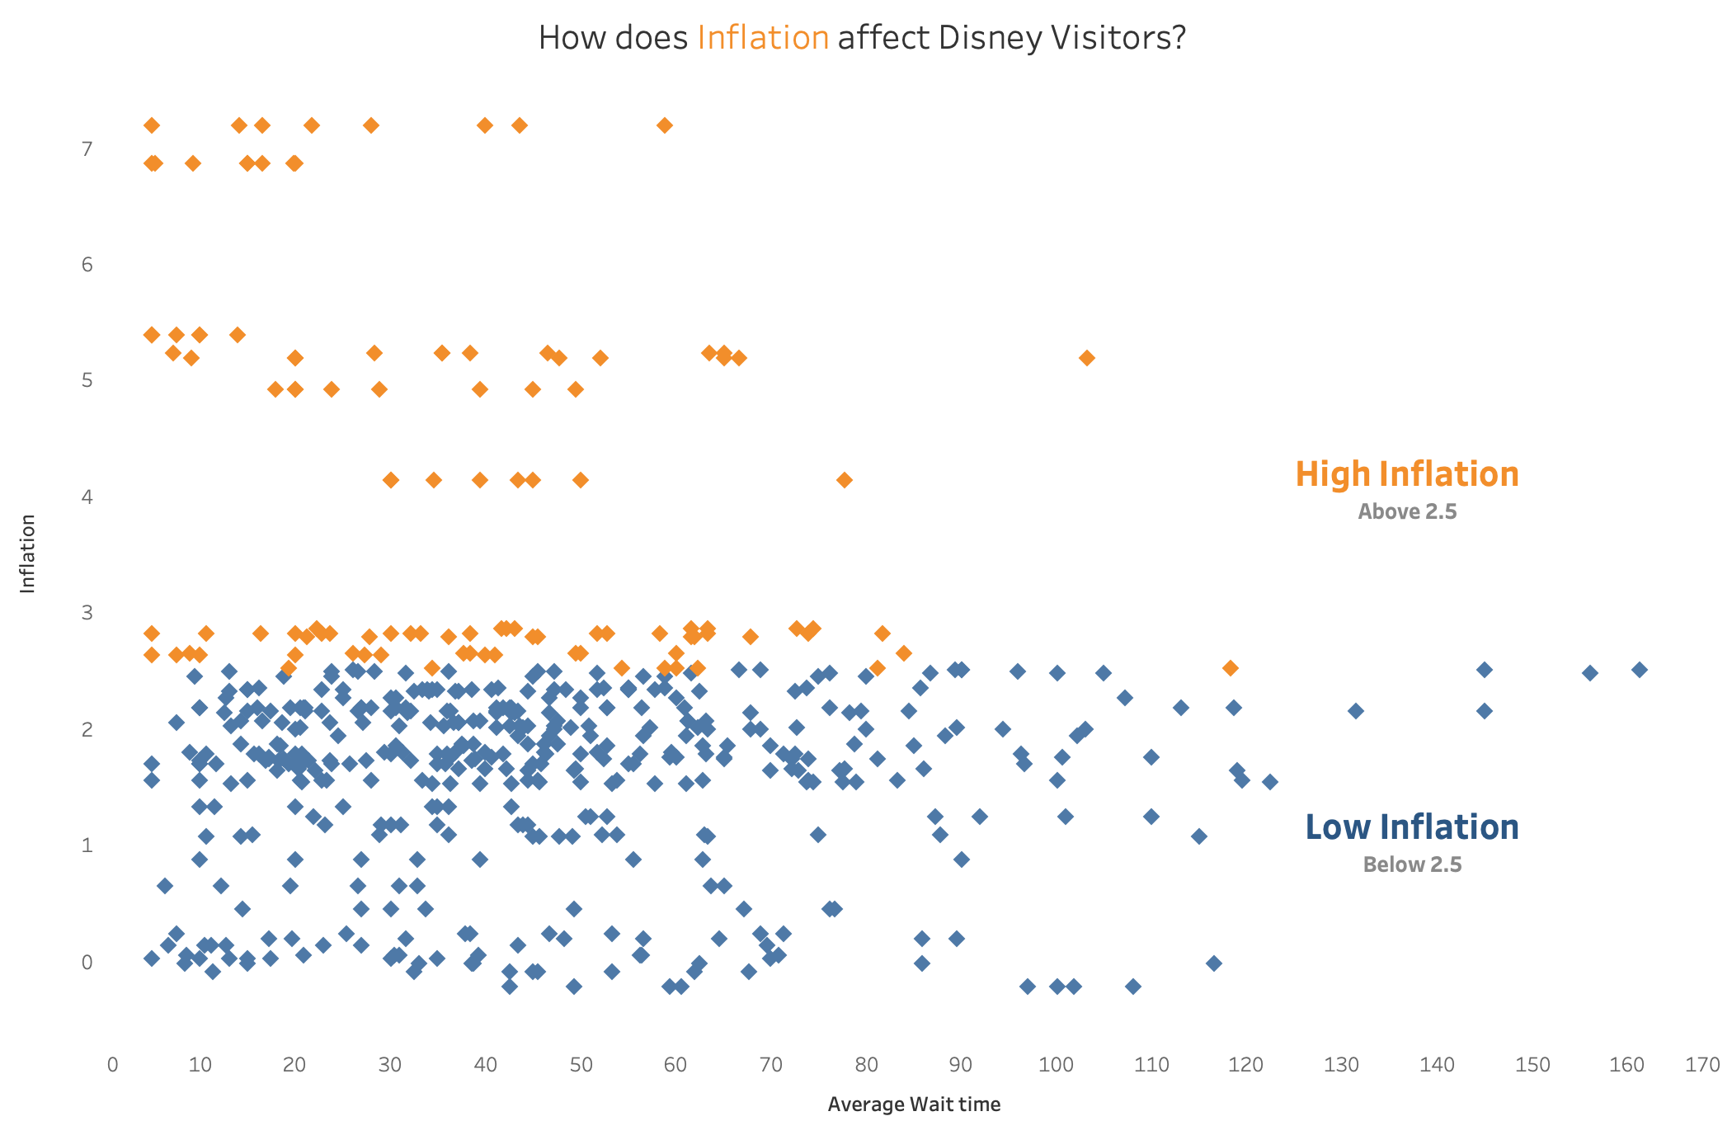

1. Is the Disney company share price related to Disney World Visitors?

Findings: There is no relation between Disney visitors and the share price, confirming my hypothesis that Disney is too diversified to suffer significant impacts on its stock price due to minor fluctuations in visitors.

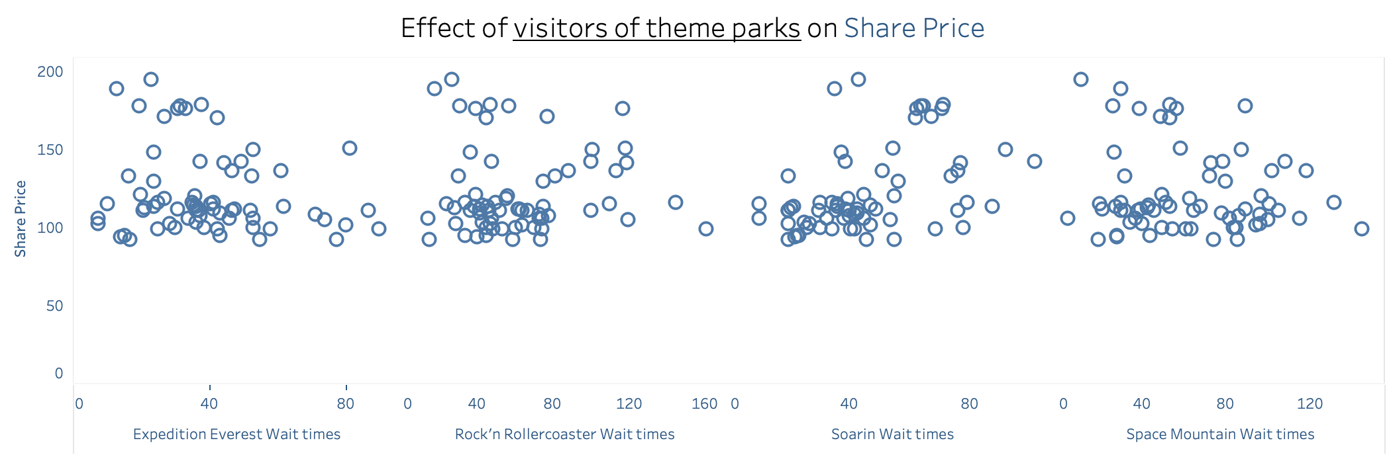

1. Are the parks having differences in how this affect them?

Findings: Comparing the different parks, it appears that economic factors are impacting Animal Kingdom more significantly. This could be due to a rebound effect caused by a decrease in visitor numbers to Magic Kingdom, which in turn results in a more substantial reduction in visitors to the other parks.

Interactive Dashboard Tableau:

https://public.tableau.com/app/profile/rodrigo.martin.vilar/viz/HowEconomicFactorsaffectdisneyparks/Dashboard4?publish=yes

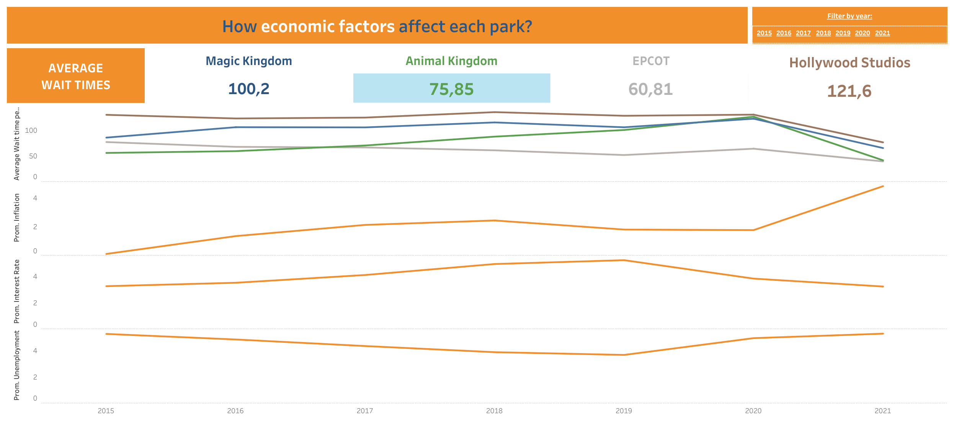

1. Are these economic factors affect families more than other groups of travelers?

Findings: The graph shows that the economic downturn in 2021, following the pandemic, has had a more severe impact on wait times for thrill rides. It is important to note that, on average, thrill rides tend to have longer wait times than family rides, which could affect the conclusion drawn from the data.

